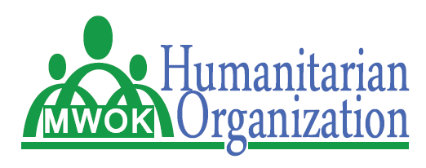

**THE PLIGHT OF DISASTER AFFECTED PERSONS IN KWEEN DISTICT**

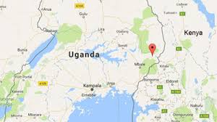

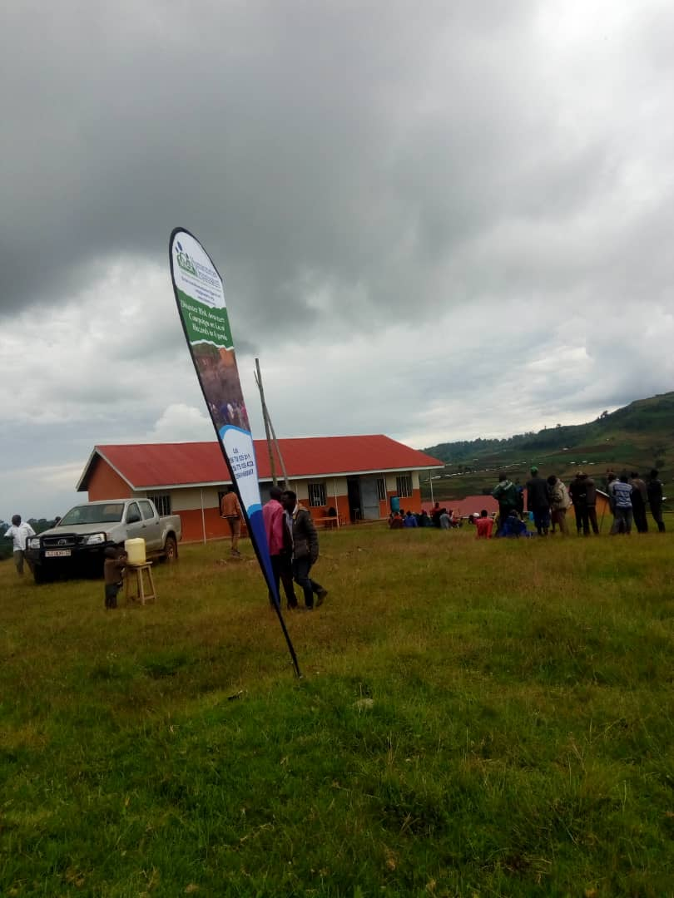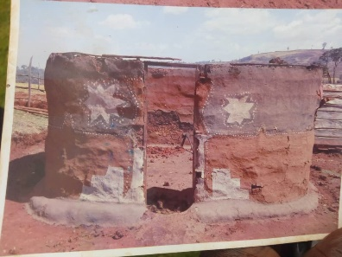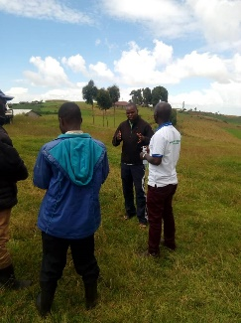

**RAPID NEEDS ASSESSMENT (RNA) IN TUIKAT, KWOSIR SUB-COUNTY-KWEEN DITRICT**

DRAFT REPORT (VER 1.0)

NOVEMBER, 2021

**RAPID NEEDS ASSESSMENT IN DISASTER AFFECTED POPULATION IN KWEEN DISTRICT**

**INTRODUCTION**

The Rapid needs assessment was conducted on 8th.11.2021 in Kween District, Kwosir sub-county. This RNA aimed at finding out what exactly happened to the disaster affected community in Kwosir sub-county. And it was intended to find out who is or are affected most and to determine the number of the affected community members or population in this area after the disaster had occurred and also to identify the type of needs these community members may require as a result of the disaster incident. The interview was conducted among key informants and Focus group discussion for both men and women and youths in the affected community.

**BACKGROUND**

Kween district was created by act of parliament and started functioning on 1 July 2010. Prior to that it was part of Kapchorwa district. The district has three town councils namely: Binyiny, Kaproron and Chepsukunya. And it is located in Eastern Uganda. Besides that it has 5 sub-counties with 19 parishes and 200 villages. And among the 5 sub-counties Kwosiri Sub-county was selected as the case study for the Rapid Needs Assessment due to the recent disaster which occurred in that area and affected some of the community members in this sub-county, it consists of 4 parishes namely; Kapsgotiny, Kere, Tuikat and Yatui. However, the RNA was conducted in Tuikat parish.

**RNA OBJECTIVES**

MWOK and the DLG of Kween through DDMC conducted rapid assessment in Tuikat Parish, the most affected areas in Kwosir Sub-county to:

1. Identify the number of affected families and persons for better response targeting;
2. Identify the urgent needs of the affected population
3. Assess the impact of disaster related to heavy rains/floods/mudslides/strong wind on the communities
4. Guide development of intervention response and mitigation/adaption plan

**RNA METHODOLOGY**

**Affected area and population:**

This RNA was conducted in most affected sub-county targeting affected people/homes/communities in Kween district. Stakeholders and opinion leaders including local political leadership- RDC, LCV, LCI and the districts Administrative and technical department (CAO representatives, Engineering, Environment/Natural Resource and Community Services Department of Kween district were represented during the RNA conducted on 8th November, 2021

**Data collection procedure**

A cross-sectional study using qualitative approach of focus group discussions, FGDs and key informant interviews. KIIs and observations/transect walks/photographs/pictorials was used during the assessment to inform the report of this RNA.

**[RNA Tool in Annex 1 and 2 were used]**

**Ethical consideration**

Participation in this RNA was voluntary through verbal consent and all information collected were kept confidential and used for its intended purpose. SOPs of MOH for COVID-19 prevention (observing personal hygiene and physical distancing) were observed at all times during the period of the RNA

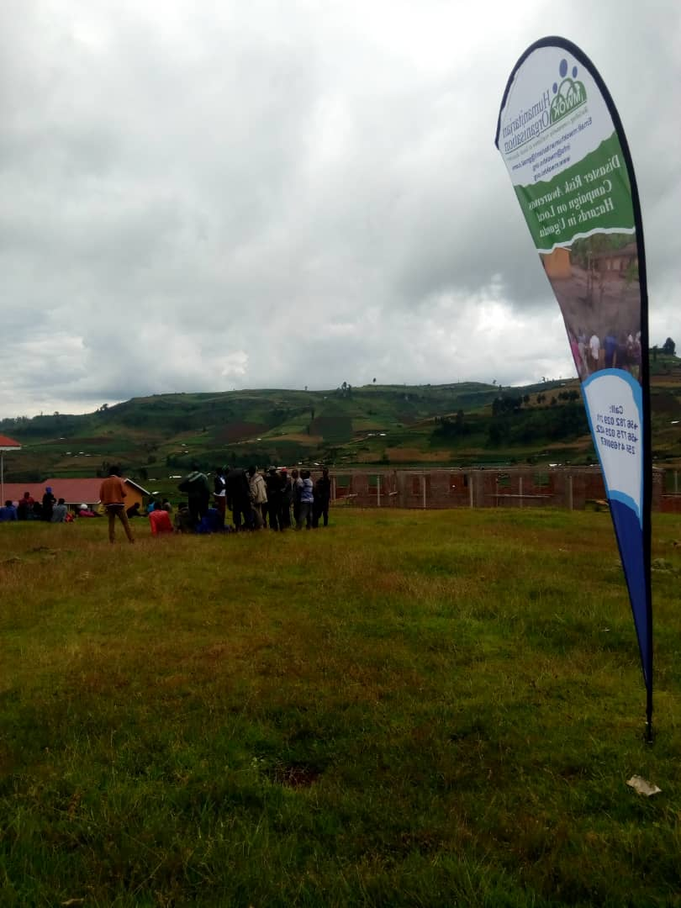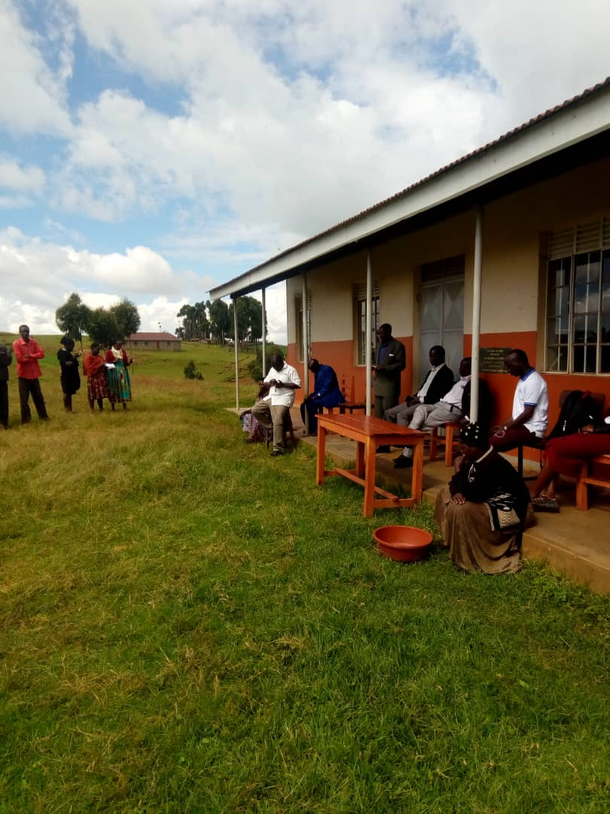

**KEY FINDINGS:**

The bullet points of key findings below summarize information obtained both from the key informants’ interviews (KIs) and the focus group discussions (FGDs) held with opinion leaders and communities in the most affected areas.

* Local hazards that commonly affect the community members or population and the ones that were mentioned included drought, floods, hail storms/heavy winds, soil erosion and mudslide.
* Hail storms, soil erosion and mudslide, are the common and most frequent occurring disasters in their area which led to loss of properties, destruction of houses/shelters, live stocks and household materials like Kitchen utensils.
* 5 villages: *Rorok, Tumbo/ seret, chekatus and Kaptang in Tuikat parish* were the most affected in Kwosir Sub-county
* 230 households affected the disasters, with 20 households with homes destroyed in-dire need of humanitarian assistance and re-settlements.
* Loss of crop garden of maize, potatoes and vegetable was reported. While Typhoid fever was reported as the common health problems.

**ROOT CAUSE OF DISASTERS IN KWEEN:**

* Soil erosion was due to the poor farming methods as farming household families/communities normally apply/or practice non-terracing approach on the hilly fertile slopes.
* Lack of trees in the area making it areas susceptible to strong winds and water falls passing through easily
* Negligence of some community members constructing and planting on the trenches hence resulting into degradation and soil erosion-quite often resulting into mudslide/landslide disasters.

**MOST AFFECTED GROUPS:**

The mostly affected population were the children, women and elderly. And the reasons they gave was, their plantations were destroyed making it hard to sustain their families in terms of feeding and getting money since their main source of food from farming and the same farm products are their source of income in the households, this therefore left them in dilemma thus children and women are affected and became more vulnerable.

Following the discussions over 20 households were severely affected by the recent disaster. This was evidenced with complete destruction of houses and properties where by the most affected families had nowhere to take cover/shelter but opted to shift at the neighborhoods for shelter for at least one week of which it has been found out that as result of the destruction two families failed to recover and opted to live at the church. In this incident there were loss of properties like beddings, clothing, kitchen wares, crops in the garden and the stored foods, money (savings), houses and a few stocks like chicken and goats which they said was not in large number. The crops that were destroyed include maize plantations of which most of the households were talking of ½ acre each, beans, Irish potatoes among others.Their main source of food is farming, and the same products are sold to buy other basic needs like salt, and change of diet which needs money or exchange.During the interview some health issues were also realized and they mentioned them as follows; psychological torture / trauma, minor injuries especially affected the children. Other findings were also related to them to the source of water they use, most of the respondents mentioned the use of unprotected springs and protected springs which they said are also affected with contamination by both human beings and animals since they share the same source of water and this contamination is through defecation and urination which has been evidenced with stomach problems and typhoid cases.

Although the disaster affected the community members, they scan still access market for basic needs since the market areas were not affected.

**RESPONSE INTERVENTIONS UNDERTAKEN:**

* Basing on the findings some politicians managed to rescue the most affected persons with beans and posho to sustain them in a short period of time.
* The Community Development Officer and Sub-County Chief provided psychosocial support to those who were most affected.

**PROPOSED RECOMMENDATIONS FOR RESPONSE AND RECOVERY ACTIONS:**

IMMEDIATE;

1. Mobilize the much-needed resources/funds from government and partners to provide lifesaving interventions such as basic food items and NFIs for the affected households, estimated at 230 households;
2. Re-settlement of 20 severely affected households; and
3. Sensitize the community to STOP using contaminate water points

MEDIUM-TERM;

1. Routine water quality assessment and treatment in hotspot areas
2. Update hazard profiles and contingency plan for each sub-county and parish in Kween,
3. Conduct Disaster Risk Awareness (DRA) using mass campaign involving everyone and every local media everywhere (leave no one behind with disaster risk information through multi-hazard early warning, MHEW)
4. Strengthening DDMC on Disaster Risk Management (assessment, analysis, planning, budgeting, resource mobilization and implementation, and M&E of disaster resilience programs)

LONG-TERM;

1. Sensitize communities on disaster prevention, preparedness and mitigation/adaptation (DRR) measures and causes of disasters.
2. Encourage tree planting as wind breakers at homes, farmlands, schools, etc. and good farming methods in uplands/hilly slopes, which have fertile soil that needs to be protected
3. Advocacy for local disaster response funds for district from key stakeholders

**Annex 1: Proposed budget for the Response, Recovery and Resilience (RR&R) Interventions**

|  |  |  |  |  |  |  |
| --- | --- | --- | --- | --- | --- | --- |
| **IMMEDIATE;** | **Target** | **Qty/freq** | **Unit Cost** | **Amount** | **Responsibility** | **Remarks** |
| i. Mobilize the much-needed resources/funds from government and partners to provide lifesaving interventions such as basic food items and NFIs for the affected households, estimated at 230 households; | 1380 | 20 | 7000 | 193,200,000.0 | CAO/DDMC/OPM | 15kgMaize flour+5kdBeans per person per month ( 6/hh) |
| ii.  Distribution costs | 1 | 1 | 1000000 | 1,000,000.0 | CAO/DDMC/OPM | Hire of Truck for 1 day distribution |
| iii        Re-settlement of 20 severely affected households; and | 20 | 1 | 500000 | 10,000,000.0 | CAO/DDMC/OPM | Cost of shelter/NFIs |
| iii.        Sensitize the community to STOP using contaminate water points | 1 | 4 | 500000 | 2,000,000.0 | CAO/DDMC/OPM | Weekly Radio Talk show/IEC mtrls |
| **SUB-TOTAL** |  |  |  | **206,200,000.0** |  |  |
| **MEDIUM-TERM;** |  |  |  |  |  |  |
| iv.        Routine water quality assessment and treatment in hotspot areas | 1 | 2 | 450000 | 900,000.0 | DISTRICT WATER DEPT | Qterly, every 3month |
| v.        Update hazard profiles and contingency plan for each sub-county and parish in Kween, | 1 | 2 | 1500000 | 3,000,000.0 | MWOK/DDMC | Hazard vulnerabiliy & capcity assessment (HVCA cost per qtr |
| vi.        Conduct Disaster Risk Awareness (DRA) using mass campaign involving everyone and every local media everywhere (leave no one behind with disaster risk information through multi-hazard early warning, MHEW) | 1 | 6 | 500000 | 3,000,000.0 | MWOK/DDMC | Monthly Risk awreness costs |
| vii.        Strengthening DDMC on Disaster Risk Management (assessment, analysis, planning, budgeting, resource mobilization and implementation, and M&E of disaster resilience programs) | 1 | 2 | 3500000 | 7,000,000.0 | MWOK/DDMC |  |
| **SUB-TOTAL** |  |  |  | **13,900,000.0** |  |  |
| **LONG-TERM;** |  |  |  | - |  |  |
| viii.        Sensitize communities on disaster prevention, preparedness and mitigation/adaptation (DRR) measures and causes of disasters. | 1 | 6 | 3500000 | 21,000,000.0 | DCDO/PARTNER | Radio jiggles played for 6months |
| ix.        Encourage tree planting as wind breakers at homes, farmlands, schools, etc. and good farming methods in uplands/hilly slopes, which have fertile soil that needs to be protected | 1 | 2000 | 5000 | 10,000,000.0 | ERM DEPT/PARTNER | 2000 trees planted/cared for |
| x.        Advocacy for local disaster response funds for district from key stakeholders | 1 | 2 | 3500000 | 7,000,000.0 | CAO/PARTNERS | Brochures/stakeholder updates on disaster issues every qtr |
| **SUB-TOTAL** |  |  |  | **38,000,000.0** |  |  |
| **TOTAL RR&R** |  |  |  | **258,100,000.0** |  |  |